ECSE 211
Design Principles and Methods

Prof. Frank P. Ferrie

Prof. David A. Lowther

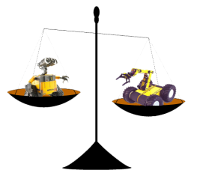

Final Report

Rana Muaddi 260163563
Kamraan Nasim Syed 260261496
George Ionut Ciobanu 260242300
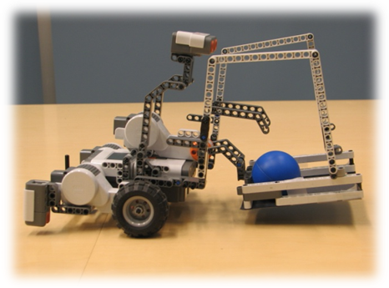
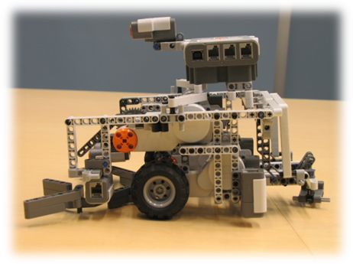
Patrick Lamaa 260254099
Yu Ming Jiao 260232016
Cong Su 260284910

